NISCHAYA SHAKYA
SOLUTION ARCHITECTURE PORTFOLIO
Power Platform Solution Lead | Solution Architect | Technical Lead

ENTERPRISE ARCHITECTURE  End-to-end ownership from problem framing to production operation | HANDS-ON ENGINEERING  Power Platform, C#, APIs, Azure DevOps and full-stack delivery | PLATFORM LEADERSHIP  Security, ALM, governance, migration and production standards
Selected work across multi-contract SaaS platforms, enterprise case management, vendor-to-internal product transition, regional Power Platform governance and AI-enabled automation.
Perth, Western Australia • 2026

Executive Profile
Solution Architect and Power Platform Solution Lead with responsibility spanning business problem definition, target architecture, hands-on engineering, security, integration, ALM, deployment, rollout and continuous improvement. The work represented in this portfolio is deliberately broader than application development: it includes enterprise platform design, multi-contract operating models, production governance, vendor transition, cloud migration, full-stack engineering, AI-assisted workflows and large-scale automation estate transformation.

What I Own
Architecture  Dataverse/domain models, solution boundaries, integration patterns, non-functional requirements | Security  Business Units, Teams, RBAC, field security, DLP, service accounts, auditability | Engineering  Power Apps, Power Automate, Power BI, C# plug-ins, JavaScript/TypeScript, APIs, full stack
ALM & DevOps  DEV/UAT/PROD, managed solutions, Git, Azure DevOps, CI/CD, release/rollback | Delivery Leadership  Discovery, POCs, technical challenge, roadmaps, RACI, UAT, mobilisation, rollout | Operations  Production governance, support models, change control, continuous improvement
AI & Automation  Copilot Studio, AI Builder/LLMs, document intelligence, classification, agentic patterns | Cross-Technology  Azure, Next.js/React, Laravel/PHP, MariaDB/MySQL, Docker, Nginx, Redis | Governance  Standards, architecture artefacts, environment policy, licensing, vendor/Cyber/ICT alignment

Portfolio at a Glance
- Marketplace System — architected and scaled a multi-contract procurement, logistics, inventory, budgeting and operational SaaS platform for remote resource-sector sites.
- Customer Feedback Management — enterprise feedback, case, action, communication and AI-assisted triage architecture on Dataverse.
- NuView Village App — inherited vendor solution, migrated into Azure/internal ownership, redesigned front end, coordinated penetration testing and established DevOps/support.
- WA Power Platform Estate — created governed environments, DLP/security architecture and deployment standards, then led migration and rationalisation of 1,000+ flows.
- HWA / Automation / AI — operational process modernisation, Copilot Studio and LLM/AI integration patterns, secure integration and governance.

Case Study 01 — Marketplace System
MULTI-CONTRACT PROCUREMENT, LOGISTICS, INVENTORY & OPERATIONS SAAS
My role: Solution Architect / Solution Lead / hands-on technical owner, from product architecture through contract mobilisation, production deployment and continuous roadmap.
Business context: Remote-site procurement and inventory processes required a governed platform that could support multiple contracts, locations, users, suppliers, budgets and operating models without creating a separate application for every site.
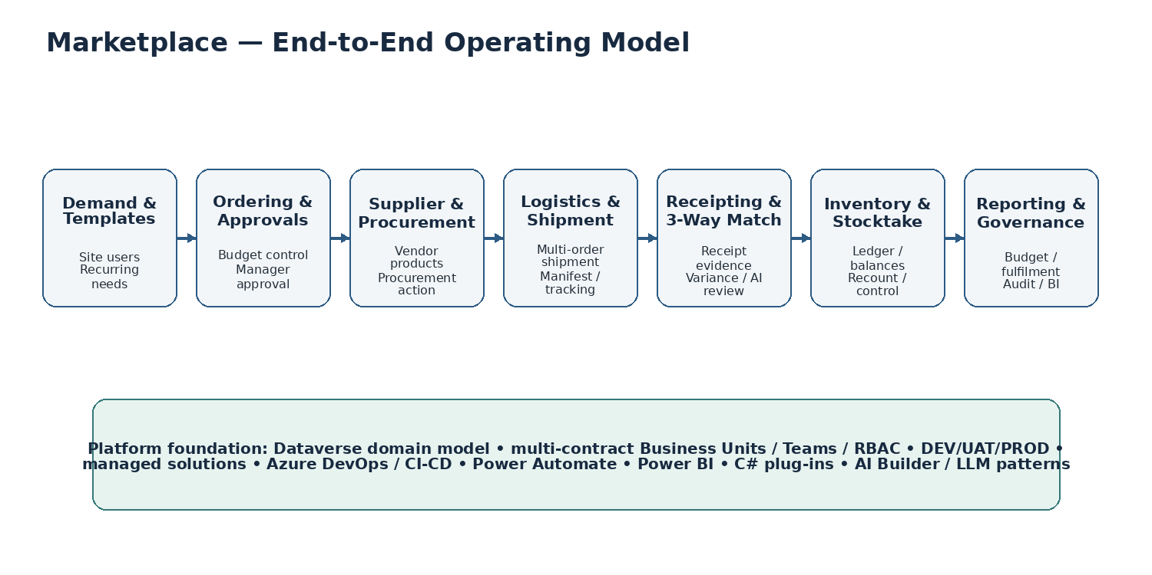

Architecture & Product Scope
- Designed Marketplace as a reusable multi-contract product rather than a single-site application, with contract/site segregation and configuration patterns that support mobilisation of new mine sites.
- Modelled the procurement domain across products, categories, vendors, site-specific catalogues, orders, order lines, fulfilment, shipments/receipts, inventory ledger, stock balances, stocktake and budget periods.
- Designed approval and order-state controls covering draft, pending approval, approved, procurement action, receipt and rejection/reconciliation pathways.
- Embedded budget logic and financial guardrails so ordering activity is tied to delivery periods and budget controls rather than operating as a simple request tracker.
- Designed inventory controls around ledgered movements, balances, stocktake periods/lines and operational reconciliation.
- Extended the platform into logistics and shipment/receipting patterns so multiple orders and order lines can be managed through real operational delivery events.

Security, Governance & ALM
- Designed Dataverse Business Unit, owner-team and security-role patterns to isolate contracts/sites while supporting central Procurement and organisational oversight.
- Used controlled record ownership, restricted delete behaviour and audit-friendly status transitions to protect operational and financial data.
- Established DEV/UAT/PROD promotion using managed solutions, environment variables, connection references, versioning, patch/roll-up practices and controlled production releases.
- Established Azure DevOps/Git source control for custom development, including C# Dataverse plug-ins and solution artefacts, with release and rollback discipline.
- Led governance through CAB/change practices and ongoing platform standards rather than treating releases as ad-hoc app changes.

Mobilisation & Delivery Ownership
- Personally led mobilisation/configuration for new resource-sector contracts and mine sites, translating procurement and operational requirements into the product configuration and security model.
- Worked directly with Procurement, Operations, Finance, site teams and technical stakeholders to challenge process assumptions, validate the target model, prepare rollout and support go-live.
- Continued the product lifecycle after go-live through user feedback, click-reduction initiatives, dashboard redesign, bulk/streamlined receipting concepts and stocktake improvements.

AI & Forward Architecture
- Designing AI-enabled receipt and shipment-document processing so manifests/receipts uploaded against shipments can be extracted, matched and reviewed against expected order lines.
- Applying intelligent document processing / LLM patterns for variable document layouts rather than relying only on fixed templates.
- Designing three-way matching concepts across purchase/order expectations, shipment/receipt evidence and actual quantities, with human confirmation for exceptions.

Selected Implementation Detail
- Implemented contract-aware product and site catalogue patterns so the same product master can be governed centrally while site/module availability remains configurable by operating location.
- Introduced Budget Week logic tied to delivery dates so commitments are associated with the correct operating period and can be reconciled when orders are rejected or changed.
- Designed fulfilment and receipt controls around expected versus actual quantities, creating the basis for variance handling rather than simply marking an entire order as received.
- Built role-specific model-driven experiences and custom-page/dashboard concepts to surface pending approvals, procurement action, overdue work and items requiring receipting.
- Defined status-driven command behaviour and validation so users cannot bypass key lifecycle controls; used Dataverse plug-ins where server-side enforcement was more appropriate than client-only logic.
- Designed stocktake as an operational process rather than a static count, including stocktake periods/lines, recount concepts and future scanning/usage-capture enhancements.
- Used team-owned records and restricted delete patterns to preserve contract history and operational auditability while keeping day-to-day access simple for site users.

Case Study 02 — Customer Feedback Management (CFM)
ENTERPRISE FEEDBACK, CASE, ACTION, COMMUNICATION & INTELLIGENCE PLATFORM
My role: Architect and Solution Lead responsible for the operating model, Dataverse architecture, lifecycle, security, automation, communications and AI-assisted review.
Business context: Feedback arrived through multiple channels and required a single governed process for assessment, ownership, action, customer communication, recognition/escalation, reporting and closure.
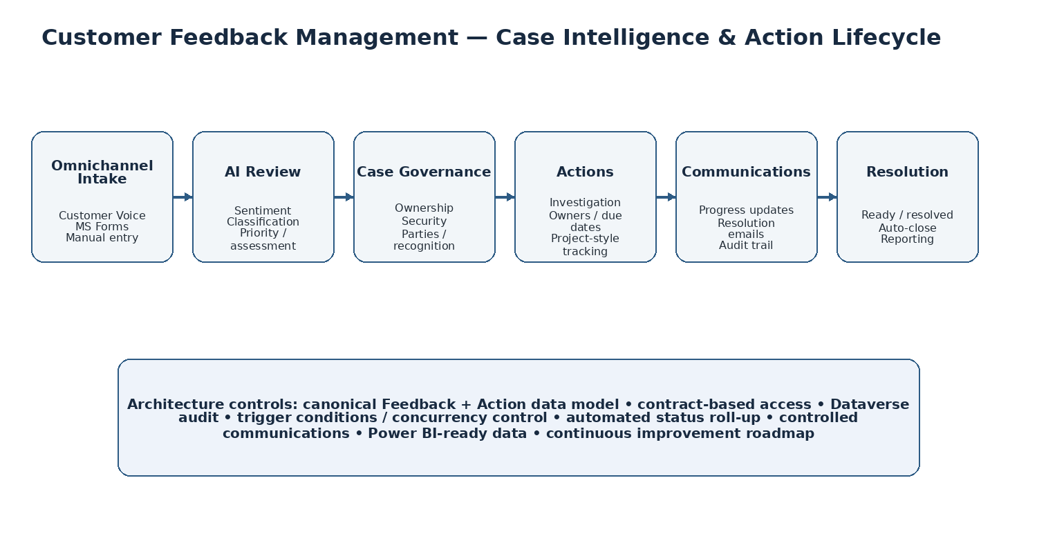

Core Solution Design
- Created a canonical Dataverse model centred on Feedback with related Actions, feedback classifications/areas, respondents and related parties.
- Designed a deliberately simple business lifecycle to avoid status noise: intake, assessment/review, action/in-progress, ready for resolution, resolved and controlled auto-close.
- Designed project-style child actions so remediation/investigation work can be assigned, progressed, cancelled/completed and rolled up to the parent feedback case.
- Designed parties/recognition patterns so employees and vendors can be linked where feedback warrants recognition or follow-up.
- Designed progress and resolution note controls, including visibility/locking rules that align with lifecycle state and prevent uncontrolled communications.

AI-Assisted Review
- Designed AI review as a baseline for users at intake: sentiment, feedback type/classification, priority and whether formal assessment is required.
- Positioned AI as decision support rather than an uncontrolled decision-maker: AI output establishes a baseline while governed business processes determine downstream handling.
- Planned use of AI Builder / LLM prompts where language understanding is valuable, with structured outputs that can be validated before updating Dataverse.

Automation & Communications
- Implemented event-driven Power Automate patterns for ingestion, assessment/status changes, child-action roll-up and controlled closure.
- Designed automated progress and resolution emails with locked sent-on/sent-by metadata, failure/success handling and run-history visibility.
- Used trigger conditions, concurrency controls and targeted Dataverse queries to avoid duplicate processing and protect lifecycle consistency.
- Designed auto-close behaviour after defined resolution/no-action periods while retaining auditable history.

Security, Reporting & Scalability
- Designed ownership, contract-based access and security rules so the solution can scale across business areas without exposing unrelated feedback.
- Structured data for reporting and governance across volume, type, priority, lifecycle, actions, response and resolution trends.
- Designed the platform for expansion into communications history, deeper recognition workflows and increasingly agentic/AI-assisted case support.

Selected Workflow & Control Detail
- Assessment is separated from raw intake so survey/automated ingestion can create a record before users are forced to complete business assessment fields.
- Priority becomes visible and required only where formal assessment is required, keeping the form clean and preventing unnecessary data entry for simple compliments or no-action cases.
- Action roll-up automation moves the parent feedback into active handling when work starts and into Ready for Resolution only when all related actions are completed or cancelled.
- Progress Notes and Resolution Notes are governed by lifecycle state, including locked/read-only behaviour after resolution so historical communications cannot be silently rewritten.
- Progress and resolution communication buttons are conditionally exposed based on case status and contact preference; successful sends stamp Sent On / Sent By metadata.
- Resolution and no-action cases are closed through scheduled automation after the defined waiting period, providing a controlled cooling-off window before final closure.
- Related Party design supports Employee, Vendor or None scenarios, allowing recognition, accountability or follow-up without forcing a single party model onto every feedback record.

Case Study 03 — NuView Village App
VENDOR TAKEOVER, AZURE MIGRATION, FRONT-END REDESIGN & INTERNAL PRODUCT OWNERSHIP
My role: Technical Lead responsible for taking an externally delivered customer application into internal technical ownership, including architecture, migration, redesign, security validation, DevOps and rollout.
Business context: Programmed needed to become self-sufficient rather than remain dependent on the external delivery vendor for code, environments, deployment and future change.
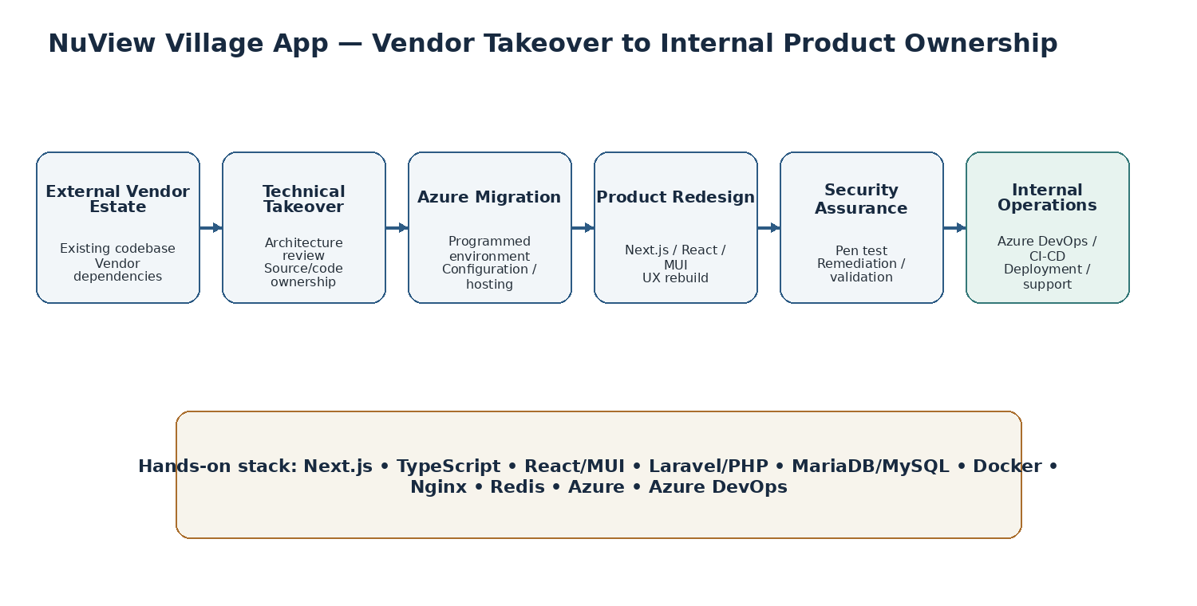

Technical Takeover & Migration
- Reviewed and inherited the existing full-stack solution, establishing a working understanding of the frontend, backend, database, container and infrastructure dependencies.
- Led migration of the application into Programmed-managed Azure infrastructure and environment configuration, including production/non-production considerations and operational ownership.
- Established source-control and Azure DevOps delivery practices so code, configuration and future enhancements are controlled internally.
- Built an isolated local Docker development/test setup spanning database, Redis, backend, Nginx and frontend services to support safe experimentation and troubleshooting.

Product Redesign & Engineering
- Redesigned the customer-facing frontend and took hands-on ownership across Next.js, TypeScript, React and Material UI rather than limiting the role to project coordination.
- Worked across the Laravel/PHP backend, MariaDB/MySQL data layer and containerised runtime using Docker, Nginx and Redis.
- Implemented role/site-driven behaviours for customer locations, including Tropicana and Sunrise Dam requirements, and continued to correct vendor-era UX/navigation and visibility issues.

Security, Testing & Delivery
- Coordinated penetration testing, defect remediation and technical validation with Cyber Security/ICT and delivery stakeholders.
- Managed vendor handover, technical dependencies, UAT findings, API validation, production configuration, release readiness and rollout.
- Reframed the application from a vendor-owned deliverable into an internally governed product with an ongoing backlog, deployment process and support model.

Selected Transition & Delivery Detail
- Reviewed inherited vendor code and infrastructure against Programmed support requirements rather than assuming the vendor architecture should be retained unchanged.
- Separated local development configuration from deployed configuration and established an isolated Docker workspace so changes could be tested without contaminating the vendor baseline.
- Worked through environment-specific configuration, health checks, database/cache services and reverse-proxy behaviour across frontend and backend containers.
- Managed role-driven experience changes for Tropicana and Sunrise Dam so site-specific content and menu functions could be delivered from a shared application rather than duplicating the product.
- Tracked UAT defects spanning navigation, dynamic content, API/master-data behaviour, required fields, images, authentication and production configuration, then drove remediation through to release.
- Established the expectation that the same versioned artefact should be promoted through DEV/UAT/PROD with configuration externalised, reducing one-off manual deployment behaviour.
- Owned the difficult middle ground between software engineering and project delivery: vendor handover, backlog prioritisation, stakeholder expectations, security dependencies, test evidence and go-live readiness.

Case Study 04 — WA Power Platform Estate Transformation
ENVIRONMENT STRATEGY, DLP, SECURITY, ALM & 1,000+ FLOW MIGRATION
My role: Regional Power Platform technical owner for the WA estate: architecture, environments, security, governance, migration, deployment standards and operational support.
Business context: A large automation estate required controlled production/non-production boundaries, security/governance, sustainable ownership and a repeatable deployment model before migration could be treated as safe enterprise change.
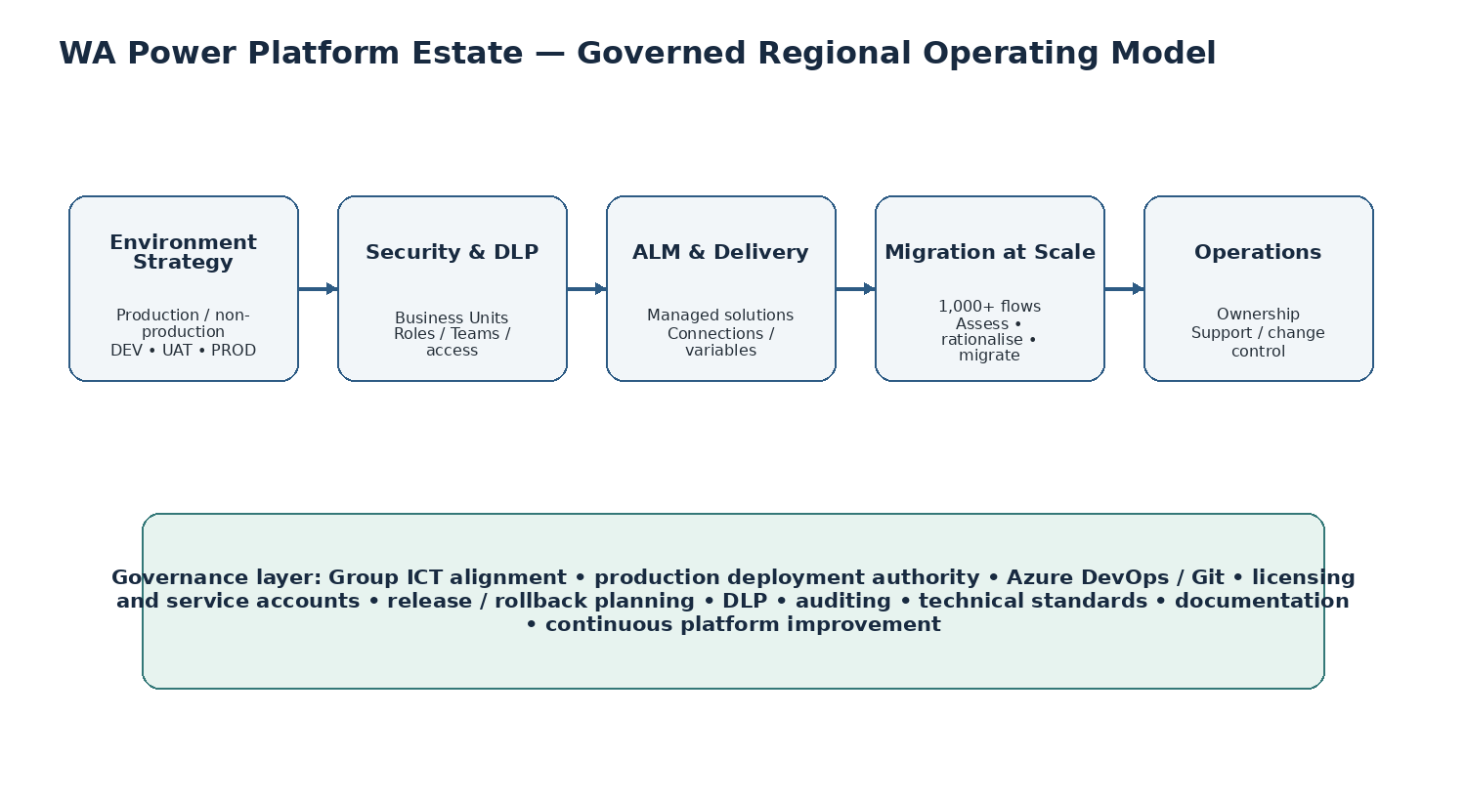

Platform Foundation
- Created and administered governed production and non-production Power Platform environments and defined DEV/UAT/PROD operating patterns.
- Configured DLP policies to control connector use and reduce unmanaged data-movement risk.
- Designed Business Unit, security-role, team and access-control patterns to support regional and solution-specific segregation.
- Standardised service-account, connection-reference and environment-variable approaches to reduce person-dependent production automation.
- Defined managed-solution, release, patching, dependency and rollback practices for controlled promotion into production.

Migration at Scale
- Took technical ownership of a regional estate of 1,000+ Power Automate flows.
- Led assessment, migration and rationalisation rather than performing a simple lift-and-shift, identifying ownership, environment, connection and support considerations.
- Moved automations into governed ownership and support structures aligned with regional operating practices and Group ICT policy.
- Established a repeatable migration/control model that supports future platform cleanup, licence management and sustainable operations.

Regional Technical Authority
- Act as a controlled production deployment point for WA Power Platform changes and automation, including support to BI and other delivery teams.
- Own standards around environment use, solution packaging, security, integrations, documentation and production change.
- Bridge local delivery with Group ICT, Cyber Security and enterprise policies while retaining enough hands-on depth to diagnose and implement technical solutions directly.

Selected Governance & Operating Detail
- Consolidated automation into governed enterprise environments to reduce shadow ownership, unmanaged connections and licence/compliance risk.
- Standardised connection references and environment variables so solutions can be promoted without hard-coded environment-specific dependencies.
- Applied base/patch/roll-up solution discipline and dependency-aware release practices to reduce production risk during schema and automation changes.
- Maintained platform documentation and reusable controls covering environment configuration, deployment methods, connection ownership, standards and solution support.
- Audited environment, licence and ownership patterns and removed or rationalised legacy artefacts where they created operational or compliance risk.
- Supported BI and business delivery teams as the regional technical gate for automation and deployment, ensuring changes fit the governed operating model before production release.
- Established CAB/change practices and aligned WA delivery with Group ICT policy while retaining a pragmatic route for urgent operational fixes and controlled rollback.

Additional Architecture & Leadership

HWA Automation & Process Modernisation
- Lead discovery and architecture for operational processes currently handled through fragmented/manual activities.
- Define the future-state workflow, supporting data model, integration points, security, automation and support approach before build.
- Use Power Automate/Power Platform where appropriate, while retaining cross-technology options where requirements or supportability demand a different approach.

AI, Copilot & Agentic Architecture
- Design Copilot Studio agent patterns using knowledge, tools/actions and instructions rather than treating agents as simple chatbots.
- Use AI Builder / LLM patterns for language-heavy tasks such as sentiment, classification, summarisation, document extraction and structured decision support.
- Design hybrid document-processing patterns: classify document type, extract/interpret content, return structured JSON, validate against business rules and require human confirmation where operational risk exists.
- Work with Cyber Security, ICT and vendors on secure third-party AI integrations, including data flow, identity/service accounts, secrets, logging and governance boundaries.
- Current use cases span feedback triage, intelligent receipting/document processing and operational support/flow-monitoring concepts.

How I Lead a Solution
1. Frame the problem | Challenge assumptions, identify root causes, understand users/operations and define what actually needs to change.
2. Define target architecture | Data model, solution boundaries, security, integrations, non-functional needs, technology selection and governance.
3. Prove the direction | POC/prototype where appropriate, validate technical feasibility and refine the operating model.
4. Plan delivery | Phases, scope, RACI, risks, dependencies, UAT, mobilisation, deployment and support.
5. Engineer the solution | Remain hands-on where needed across Power Platform, C#, JavaScript/TypeScript, APIs, Azure or full-stack components.
6. Govern release | ALM, security review, testing, production change, rollback, documentation and stakeholder readiness.
7. Operate as a product | Monitor, support, improve, automate further and continue CI/CD after go-live.

Technical Breadth
Microsoft Power Platform | Power Apps (Model-Driven, Canvas, Custom Pages), Power Automate, Power BI, Dataverse, Dynamics 365, Copilot Studio, AI Builder, Power Fx
Custom Engineering | C# Dataverse plug-ins, JavaScript/TypeScript, REST APIs, custom connectors, SQL, Python, command-bar extensions
ALM & DevOps | Azure DevOps, Git, CI/CD, managed solutions, versioning, patches, environment variables, connection references, release/rollback
Security & Governance | Business Units, Teams, RBAC, field security, DLP, service accounts, auditing, environment strategy, change control
Full Stack / Cloud | Azure, Next.js, React/MUI, Laravel/PHP, MariaDB/MySQL, Docker, Nginx, Redis, third-party AI/integration services

Selected Governance & Architecture Artefacts
The value of architecture is not only the diagram. I produce the artefacts and controls required to make a solution buildable, supportable and auditable.
- Current-state / future-state process maps and solution option assessments.
- Architecture overviews, domain/data models, ERDs and integration/data-flow diagrams.
- Security architecture covering Business Units, Teams, RBAC, field controls, ownership and DLP.
- Environment strategy, connection-reference / environment-variable design and service-account approach.
- Delivery roadmaps, phased project plans, RACI, risk/dependency registers and mobilisation plans.
- UAT strategy, defect triage, release readiness, deployment runbooks, rollback planning and hypercare/support models.
- Technical standards for Power Platform solutions, automation, configuration and deployment.
- Change/CAB material, decision records, support documentation and continuous-improvement backlogs.

Professional Positioning
The common thread across these engagements is technical ownership. I am comfortable moving from an executive or operational problem into architecture, then down into the actual engineering detail required to make the solution work, and back up into governance, rollout and long-term operation. I do not treat Power Platform as the answer to every problem; I use it as part of a broader architecture where Dataverse, Azure, APIs, custom code, full-stack applications and AI services can be combined when that produces the stronger enterprise outcome.

Role Alignment
- Power Platform Solution Architect / Solution Lead
- Technical Lead / Lead Power Platform Engineer
- Enterprise Business Applications Architect
- Digital Solutions / Automation Platform Lead
- Low-Code / Intelligent Automation Architect

NISCHAYA SHAKYA • PERTH, WA

